HGNC gene symbols and gene stable IDs associated with the Shwannoma phenotype were exported as a TSV file from Ensembl Biomart, available in genes and gene ids associated with shwannoma.txt.

HGNC gene symbols associated with the Shwannoma phenotype were exported as a TSV file from Ensembl Biomart, available in perliminary_gene_list.txt.

HGNC gene symbols associated with the Shwannoma phenotype exported from Ensembl biomart were used as an input in the STRING (Homo sapiens) database.

72 query items mapped to HGNC genes, 72 matched enteries before generating the network.

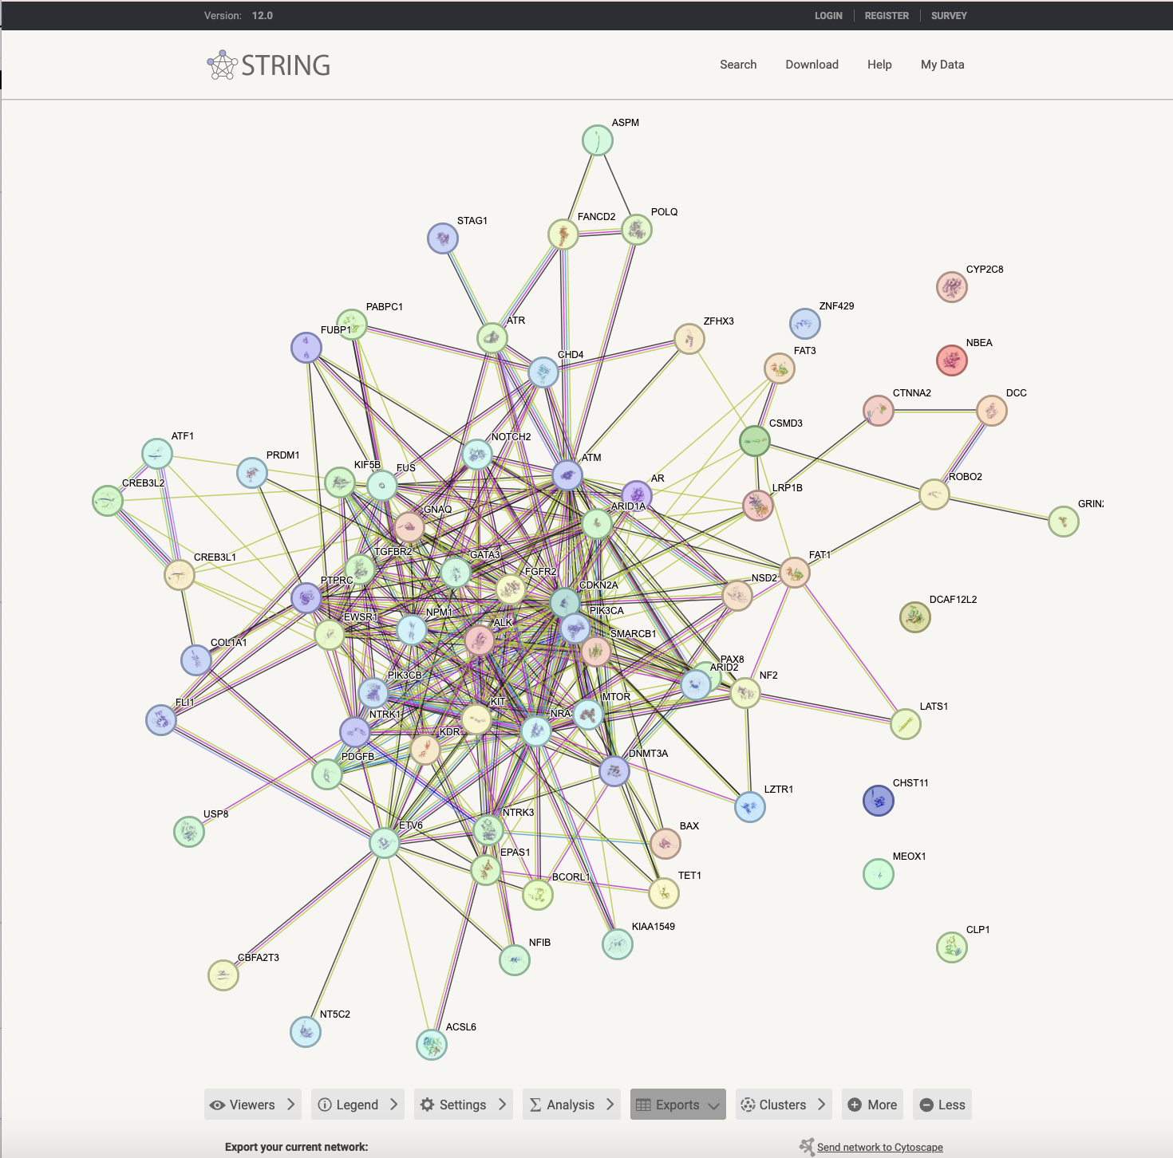

STRING PPI network from Schwannoma gene list, before applying the first shell equal to 100 interactors expansion. Default view: query proteins only

STRING settings used for expansion: network type, active interaction sources, medium confidence (0.4), max number of interactions to show=100, 2nd shell=none

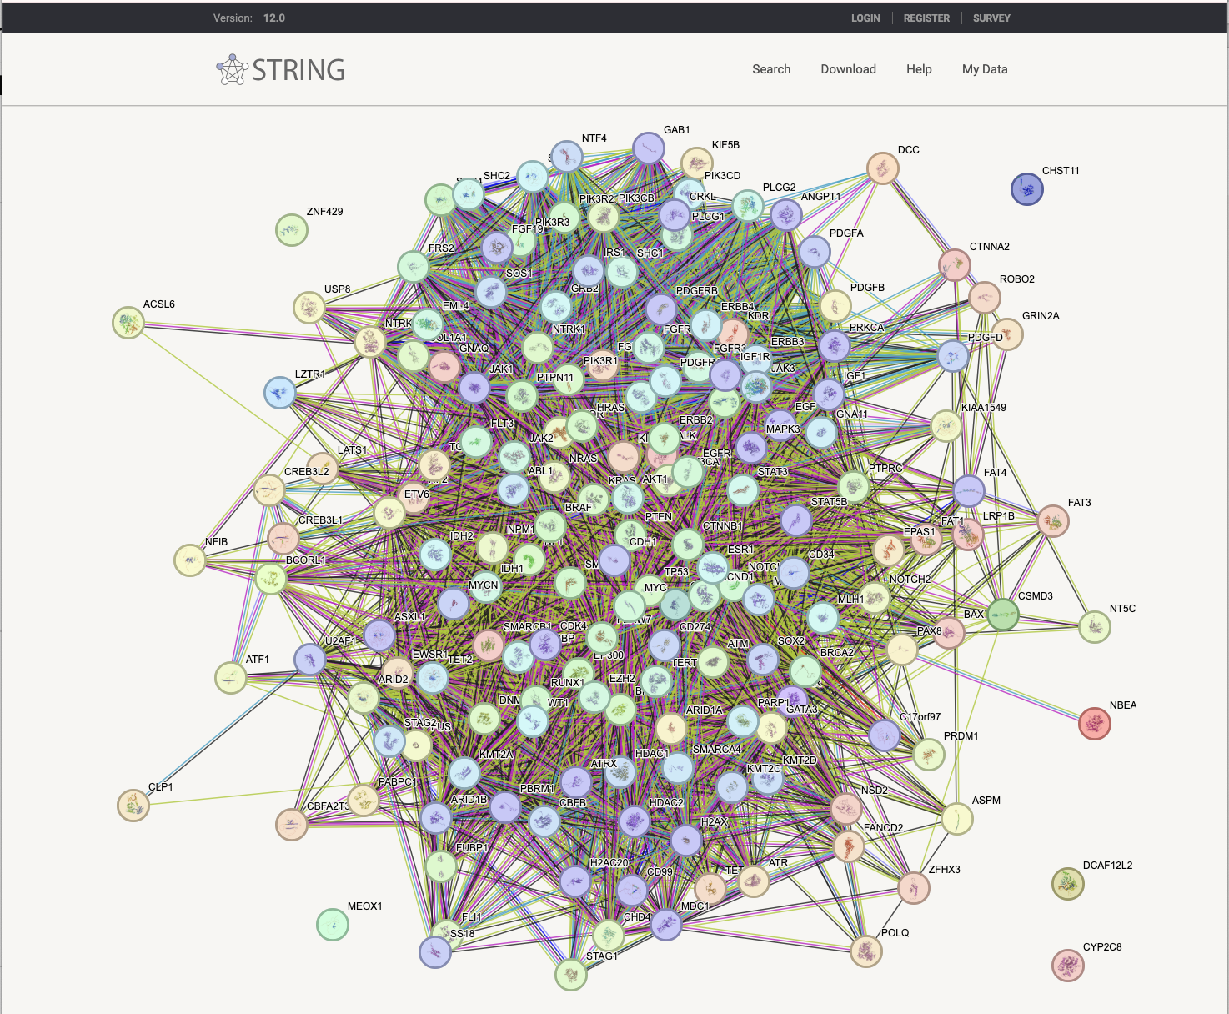

PPI network after 1st shell expansion of shwannoma seed genes in Homosapiens (STRING v12.0). Settings: evidence view, min confidence =0.4, max 100 interactors, 2nd shell = none. Nodes are proteins and edges are evidence colored associtions, thicker lines indicate higher confidence. Short tabular text output (TSV) file was exported for the interaction list, available in string_interactions_short.tsv.

Then the all genes from node 1 and node 2 were combined into one column. Next, duplicate genes were removed. The resulting gene list was used as an input for Ensembl Biomart to retreieve dSNP SNP/indel annotations, available in STRING_gene_list.txt.

Genes from STRING (STRING_gene_list.txt.) were used as an input this time. Filters were selected for germline variant source and multiple types of variant consequences were defined to avoid data overload.

HGNC symbols were converted into ENSEMBL ID (gene stable ID), available in ensemblids_string.txt.

Then, IDs were inputted into Ensembl/Biomart under the Human variation 115 dataset, in the GENE tab with the following filters and attributes

